Simplified pipelined ALU for reduced power and complexity
¹ Mr.M.Ramana Reddy,² Mr.B.Ajantha Reddy,³ Mudavath Rutha Bai,⁴ Midiganti Kameswari,⁵ Anekalla Manasa,⁶ Eraganaboina Samatha,
¹ Assistant Professor, Department of ECE, Krishna Chaitanya Institute of Technology & Sciences, Markapur.
² Assistant Professor, Department of ECE, Krishna Chaitanya Institute of Technology & Sciences, Markapur.
^{3,4,5,6} Student, Department of ECE, Krishna Chaitanya Institute of Technology & Sciences, Markapur.

Abstract— In order to improve computer efficiency, this research investigates the design and synthesis of a 4-phase pipelined Arithmetic Logic Unit (ALU). Through the use of overlapping instruction executions, the pipelined architecture—which includes fetch, decode, execute, and write back phases—increases throughput and decreases latency. In order to meet timing, area, and power limitations, the ALU is designed using one of many Hardware Description Languages (HDL), such Verilog. It is then synthesized into a gate-level representation. The results demonstrate that processing performance and efficiency are considerably enhanced by the 4-phase pipelined ALU. The following terms are used in the index: Arithmetic Logic Unit (ALU), 4-Phase Pipeline, Performance Optimization, Design, Synthesis, and Hardware Description Language (HDL).

I. INTRODUCTION
To meet the needs of increasingly complex applications, contemporary computing must significantly improve processing efficiency. An ALU (Arithmetic Logic Unit) with four phases of pipelined architecture and great performance is the subject of this research. At its core, this study revolves on the use of Hardware Description Languages (HDL) such as Verilog, which are crucial for describing and executing the intricate ALU architecture. The suggested ALU aims to make considerable gains by using pipeline methods, which include the retrieve, decode, execute, and write back stages. The realized design of the ALU is shown in Figure 1.
The efficiency of this 4-phase pipeline architecture is investigated using rigorous performance enhancement methodologies, with a focus on how each step adds to the overall computing efficiency. During the synthesis step, the high-level design that is based on HDL is transformed into a representation at the gate level.We advise a 4-Phase CGGC Pipelined architecture for a low-power pipelined ALU design. Improving processing performance via effective pipelining is the focus of this article, which delves into the nuts and bolts of ALU design and synthesis. The study aims to advance the state-of-the-art in high-performance ALU design using these techniques.
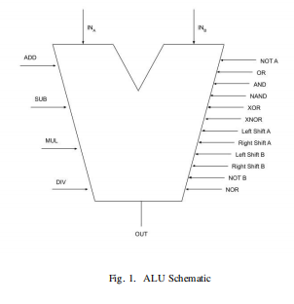
II. LITERATURE SURVEY
The performance gains in a four-phase self-timed domino logic ALU using two-phase and four-phase clocking methods, overlapping pipelining, and skew tolerance are investigated in the study "Multiphase Pipelining in Domino Logic ALU" by Swati Verma [1], Anita Angeline A, and Kanchana Bhaaskaran V S. This method outperforms single-phase pipelined ALUs in terms of speed(60%) and power savings (30%) while reducing computation time (70% with two-stage overlapping pipelining and 44% with four-stage overlapping pipelining). Nevertheless, the system is confronted with issues such as power-hungry continuous clocking, glitch-prone domino logic, area overhead for skew-tolerant circuits, and scalability limitations in multi-phase clock management. Clock gating [2] with the gray coding approach is used by Oliver et al. to address these restrictions. This approach reduces dynamic power use more than conventional techniques as it only activates the clock for active ALU steps. Reduced noise and timing issues are two benefits of grey coding that contribute to seamless transitions. Clock skew is reduced as a result of effective clock control in CGGC.
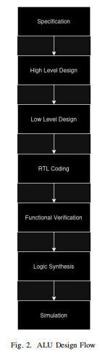
In their paper titled "ASIC Implementation of Pipelined ALU," the authors Omkar Dave, Deepak Singh Yadav, Jay Kothari, and Jayakrishnan P. [3] show how pipelined ALU designs may improve performance. Their design results in a 25% decrease in latency. The technique highlights the trade-offs in resource use, as it leads to a 54.08% increase in electricity consumption and an 18.25% increase in area. In order to overcome these limitations, we used a CGGC method, which selectively activates clocks for active stages of the pipeline, which stands for 4-phase Clock Gating [4]. Compared to standard pipelining processes, this strategy reduces dynamic power utilization more effectively. Also, clock gating [5] decreases clock skew and area overhead, while gray coding lessens signal glitches. By eliminating the drawbacks mentioned by Dave, the CGGC method greatly improves upon traditional pipelined ALUs in terms of power efficiency, stability, and scalability.
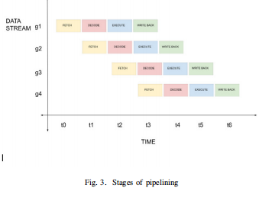
III. METHODOLOGY
The steps required in creating an Application Specific IC are shown in Figure 2, which demonstrates the design flow. We used Xilinx Vivido for the construction and simulation of our low-power ALU design technique, with an emphasis on clock gating [6] and Gray en coding in a pipelined architecture. To process instructions simultaneously, an ALU uses a four-pipeline architecture that includes fetch, decode, execute, and write back. The functional pipelining is shown in Figure 3, while the schematic of the developed ALU is shown in Figure 4. An individual part of the learning cycle is the center of attention at each stage. By judiciously integrating clock gating [7] into pipeline stages, we may reduce power usage and wasteful switching during idle periods. This is achieved by ensuring that clock signals are only delivered to active components. This selective gating may be precisely timed to work with Vivado's pipelined architecture, allowing for optimal power savings with no impact on data flow between phases.
The A and B input signals were further reduced in power consumption by using Gray encoding in addition to clock gating. By ensuring that only one bit changes at each transition, grey encoding effectively minimizes signal toggling and saves electricity. The ALU [8] makes great use of this since inputs undergo many rapid changes. In order to reduce dynamic power, this encoding strategy is really beneficial.
A potential source of increased power consumption is the prevalence of simultaneous bit transitions in inputs encoded in binary. Xilinx Viado was used for both the development and testing of the architecture. Our method's power savings were confirmed by functional simulations, which also confirmed that each step of the pipeline operated as expected. In terms of performance metrics and power consumption, the combined effects of clock gating [9] and Grey encoding for A and B inputs resulted in substantial power reductions compared to a conventional ALU. These findings validate our low-power ALU design techniques, and also open the door to the possibility of investigating adaptive clock gating [10] and additional encoding improvement for potential high-performance uses in the future.

IV. OBSERVATIONS
When comparing the non-pipelined and pipelined CGGC ALU designs in terms of I/O use and power consumption, we saw significant gains in resource efficiency and power savings. In order to keep processing data continuously, the non-pipelined CGGC ALU employed 85% of its input/output resources and used a lot of power (5.883 W for the result pin and 13.218 W for the top module).
The high power consumption and I/O demand are hallmarks of non-pipelined systems, which perform all processing operations in a single cycle. Because of this, the system as a whole uses more energy and concentrates its resources. Figure 6 displays the simulation's outcome, whereas Figure 5 displays the RTL perspective of the suggested ALU.
The pipelined CGGC ALU, on the other hand, saw a dramatic decline in I/O utilisation to 55%. I/O resources are reduced by the pipelined architecture, which divides data processing into four stages: fetch, decode, execute, and write back. This enables each step to handle data sequentially while reducing the power needs of individual components.
Compared to the non-pipelined manner, this staged construction significantly reduced the power consumption of the top module to 4.574 W and the result pin to 4.42 W. The different ALU settings are shown in Figure 7. For applications that prioritize low energy consumption, these drops show how pipelining may maximize resource utilization and power efficiency. Also, there was a reduction in power consumption at the input pins. From 3.147 W in the non-pipelined design to a mere 0.056 W in the pipelined version, the power consumption of the A and B pins was substantially decreased. This steep decrease is the result of clock gating and gray encoding working together to reduce power usage and unnecessary signal changes. The design is suitable for low-power applications because of the combined effects of clock gating, gray encoding, and pipelined architecture, which reduce power consumption overall. Based on these results, the proposed architecture is a great fit for low-power embedded systems like the Internet of Things (IoT) since it is both efficient and careful with resources.
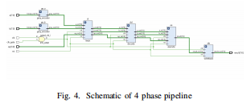
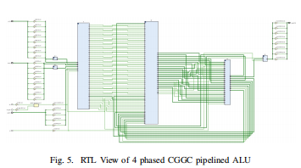
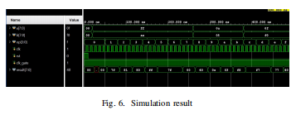
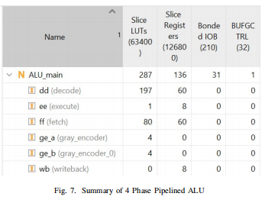

V. CONCLUSION
It is shown in this research that a high-performance 4-phase pipelined Arithmetic Logic Unit (ALU) architecture may optimize power consumption and enhance processing efficiency. By dividing tasks into retrieve, decode, execute, and write-back phases, the pipelined ALU increases efficiently. Reduced energy consumption and resource usage were the results of incorporating power-saving methods, especially Gray encoding and clock gating. With a power reduction of 13.218 W for the top module and a power reduction of 5.883 W for the result pin, the suggested design produced an increase in I/O efficiency of up to 55% and achieved significant power savings compared to non-pipelined designs. The 4-phase pipelined ALU is well-suited for use in embedded systems and the Internet of Things (IoT) because to its low power consumption and resource efficiency. The findings provide credence to the practicality of ALU design features such as clock gating, pipelining, and grey encoding, offering a practical solution to modern computing issues. Further study might lead to improved adaptive power-saving approaches, which could expand the usage of high-efficiency designs in increasingly demanding computing situations.

REFERENCES
[1] S. Verma, A. Anita Angelina, and V. S. Kanchana Bhaaskaran, “Multiphase pipelining in domino logic ALU”, 2017 International Conference on Nextgen Electronic Technologies: Silicon to Software (ICNETS2).
[2] J. P. Oliver et al., “Clock gating and clock enable for FPGA power reduction”, Eighth Southern Conference on Programmable Logic, pp. 1-5, 2012.
[3] O. Dave, D. S. Yadav, J. Kothari, and P. Jayakrishnan, “ASIC implementation of pipelined ALU”, 2013 International Conference on Green Computing, Communication and Conservation of Energy (ICGCE).
[4] J. Shinde et al., “Clock gating - A power optimizing technique for VLSI circuits”, IEEE India Conference, pp. 1-4, 2011.
[5] J. Castro et al., “Optimization of clock-gating structures for low leakage high-performance applications”, Proceedings of IEEE International
Symposium on Efficient Embedded Computing, pp. 3220-3223, 2010.
[6] S. K. Teng, “Regional clock gate splitting algorithm for clock tree synthesis,” IEEE International Conference on Semiconductor Electronics, pp. 131-134, 2010.
[7] P. Babighian et al., “A scalable algorithm for RTL insertion of gated clocks based on ODCs computation,” IEEE Transactions on ComputerAided Design of Integrated Circuits and Systems, pp. 29-42, 2005.
[8] V. Khorasani et al., “Design and implementation of floating point ALU on an FPGA processor”, IEEE International Conference on Computing, Electronics and Electrical Technologies, pp. 772-776, 2012.
[9] S. Huda et al., “Clock Gating Architectures for FPGA Power Reduction”, International Conference on Field Programmable Logic and Applications, pp. 112-118, September 2009.
[10] Y. Ijarwal, et al., “An efficient ALU architecture design for low power IoT application”, International Conference on Advancements in Smart, Secure and Intelligent Computing (ASSIC), 2024.

